The Computer Mouse
History

A mouse is a device that is connected to the computer and provides the possibility of a pointer on your screen. A mouse is classed as an input device. A mouse contains of a shell that is formed to fit the users hand. On the underside of the device is either a mechanic or optical construction that reads the motion that is made witch the mouse, and then transfers it on to the screen. On the upper side of the mouse is equipped with one or more buttons. The mouse is often used with a mouse pad and that is because it gives the mouse more accuracy.
The computer mouse were invented by Douglas Engelbart in 1964, when he was working at the Stanford Research Institute. This particular mouse read the motion with two wheels on the underside of the device, but still worked as the mouse does todayThe name mouse comes from the early models of the device which had a cord attached to the rear part of the device, suggesting the idea of a tail.
There are three different mouse types:
The Mechanical Mouse
This is the old one that has a ball in it, and when u move the mouse the ball moves and transfers the motion to two wheels and from there to the screen. This model is not used anymore because it is outdated and it won't operate everywhere.
The Optical Mouse
This mouse is the most used mouse type today, because it is more modern then the mechanical and still pretty cheap. It works with an little optical sensor inside. It is also used more than the mechanical one because you don't have to cleans any balls in this one, and it will operate on almost any place.

The Laser Mouse
The laser mouse is top of the art technology and is not used as an office mouse and it is not either the mouse you buy if you have a home workstation. This model is being used by them who wants a very god accuracy and speed and wants the option to change the speed of the mouse (sensitivity). And the users that wants this is often people who plays games.
Cord or Cordless ?
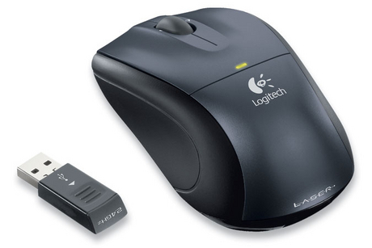
The mouse can also be cordless or with o cord, that is an option the users has. If they chose an mouse with a cord the cord is plugged into either a PS/2- or USB port. If the user prefers a cordless mouse, the mouse will not have any cords and just a little receiver that receives the radio signals from the mouse will be plugged into a USB port. There are two types of receivers one that looks just like a flash memory stick and one that is like a little box that has a cord connected to it. If you have a receiver witch a cord, you can then place the receiver almost anywhere you want just as long as it is in rage for the radio waves coming from the mouse.
A world without the mouse
So if the mouse would not have been invented of Douglas Engelbart in 1964 would the whole computer situation been different today. We would be obligated to do everything on the computer with the keyboard, I personally believe that if the mouse would not have been invented not as many as today would have an PC at home. Just think an simple task as opening an program would have to be done witch the arrow keys and the enter key. So the most computer users I know use their PC for gaming, but if there were no mouse what would they play? Packman, of course it would be nice in the beginning but after a week or to it surely would be pretty boring. So I am very pleased that the mouse have been invented, because there is nothing better than to come home after the school on a rainy day and just put on your computer and chat with your friends and play some games online.

